1. whole brain effect of stimulus type
S>A>W>I

2. WB and ROI type differences across sessions alpha =0.05/4 = 0.0125
WB | Aud | Frontal | Motor
A1 > A2  I1 = I2  S1 > S2  W1 > W2 (auditory)  W2 > W1 (insula cluster) | A1 > A2  I1 = I2  S1 > S2  W1 > W2 | A1 = A2  I1 = I2  S1 > S2  W1 = W2 | A1 = A2  I1 = I2  S1 = S2  W1 = W2
ATBL >? AL (small aud?)  ITBL = IL  STBL > SL  WTBL < WL (insula) | ATBL = AL  ITBL = IL  STBL = SL  WTBL > WL | ATBL = AL  ITBL = IL  STBL = SL  WTBL = WL | ATBL = AL  ITBL = IL  STBL = SL  WTBL = WL
AUL1 AUL2  IUL1 IUL2  SUL1 SUL2  WUL1 WUL2 | AUL1 > AUL2  IUL1 = IUL2  SUL1 = SUL2  WUL1 = WUL2 | AUL1 = AUL2  IUL1 = IUL2  SUL1 = SUL2  WUL1 = WUL2 | AUL1 = AUL2  IUL1 = IUL2  SUL1 = SUL2  WUL1 = WUL2

3. interaction of ses and type across whole brain
S1-S2 across whole brain
S>A=I>W

Aud Ses 1 vs Ses 2
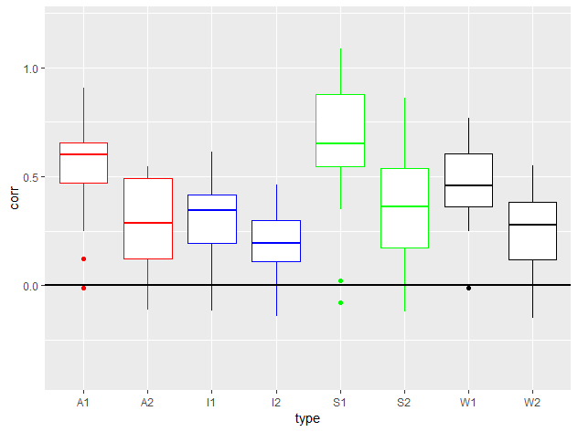

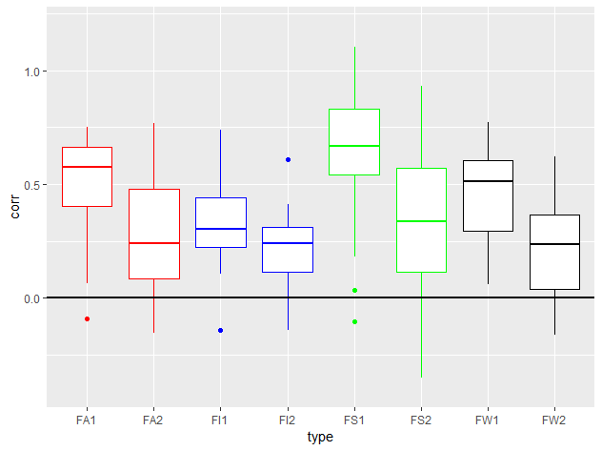
Aud Familiar 1 vs Familiar 2

Aud Unfamiliar 1 vs Unfamiliar 2
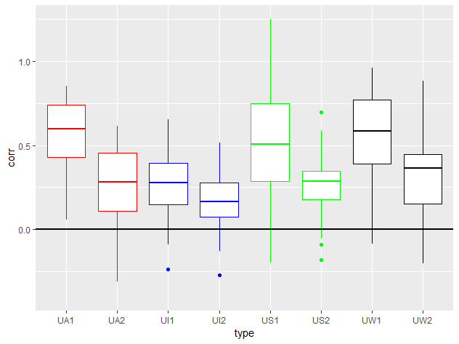
Frontal Ses 1 vs Ses 2
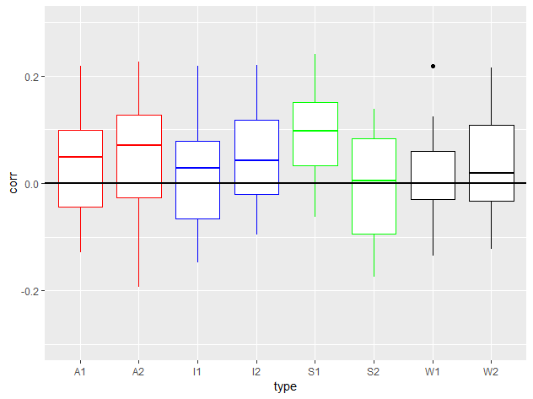

Frontal Familiar 1 vs Familiar 2
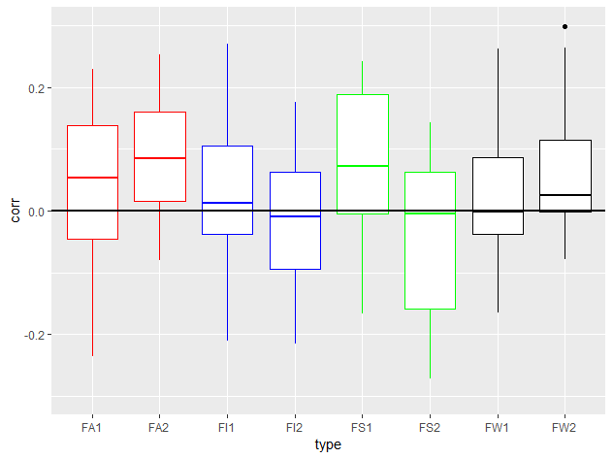

Frontal Unfamiliar 1 vs Unfamiliar 2
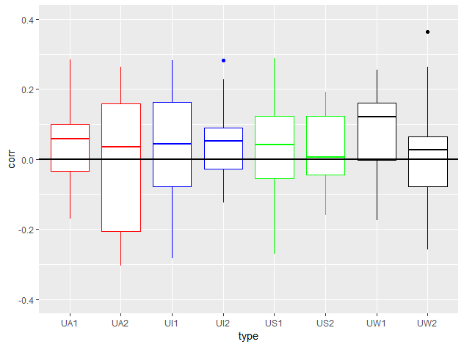
Motor Ses 1 v Ses 2

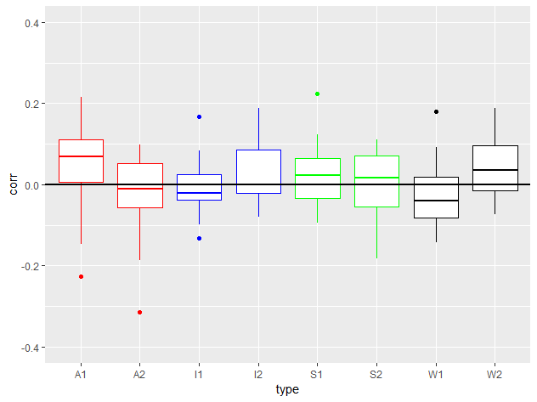

Motor Familiar 1 v Familiar 2
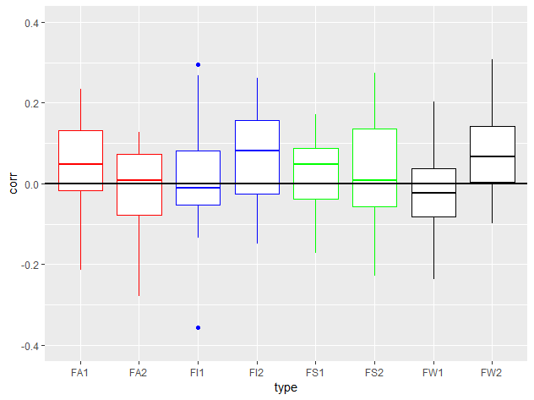

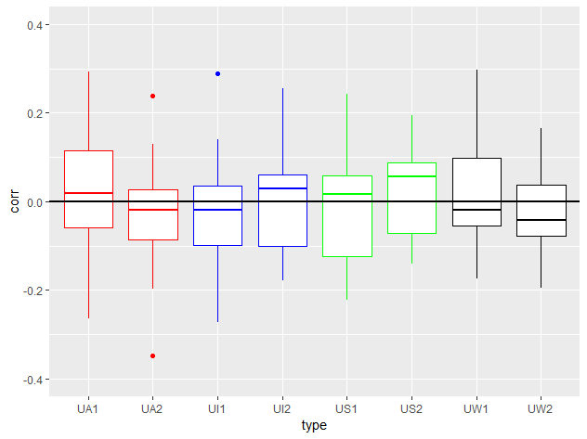
Motor Unfamiliar 1 vs Unfamiliar 2

